Chapter 3 programming practice

# Semaphore sample

Study the semaphore sample demo.

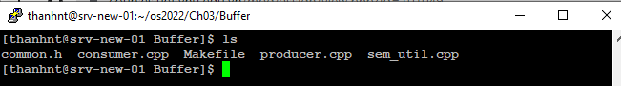

The demo includes three programs:

+ Producer.cpp => write the data into the shared buffer

+ Consumer.cpp => read the data from the shared buffer

+ sem_util.cpp => the shared semaphore library.

## Compile the demo

Run make

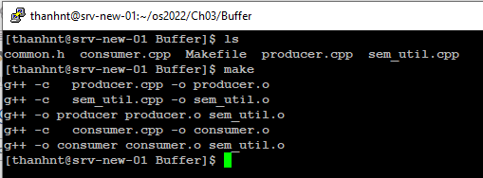

## Run demo

Open two putty session to run two programs concurrently

+ Run producer first

It stops when the buffer is full.

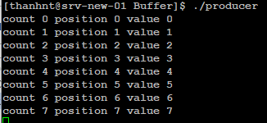

+ Run consumer next

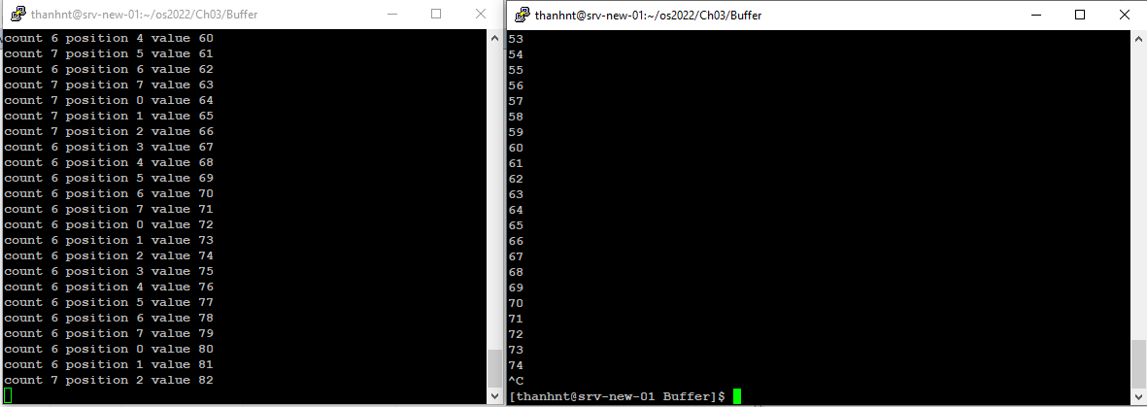

The two programs send data from producer to consumer

Press ctl+c to stop the infinite loop programs

# Problem

Modify the sample to send the content of a file from Producer to Consumer.

* The default file name (for sending) is input.dat
* The expected file name from the consumer is output.dat
* The file is in either text or binary format
* The producer exits when the data is sent
* The consumer exits when all the data is received and saved to output.dat

## Info

* The common.h file is modified for storing the data.
* The buffer is now in char data type: each time send a byte from the provider to consumer.
* done variable is to mark the end of the file (all the bytes of the file is already sent). One of the conditions to exit the loop

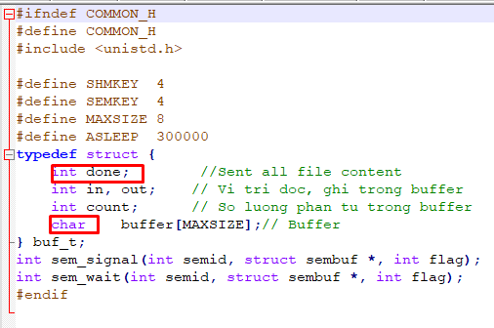

## Running expectation

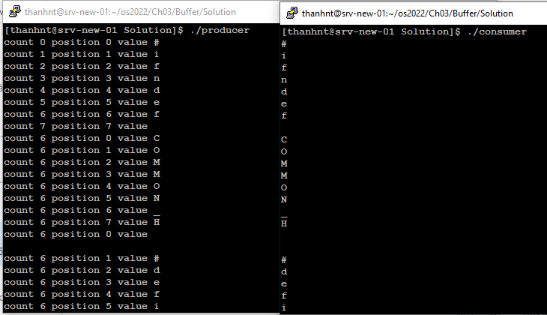

The result

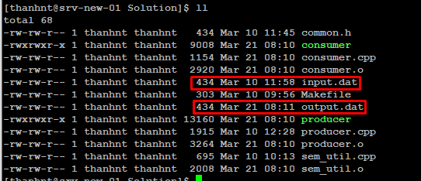

## Hint

+ Producer: reads each byte from the file and puts it into the buffer. Exit when the file is all sent.

+ Consumer: gets each byte from the buffer and writes it to a new file.

NOTE:

Write your name and student ID in the first line of the producer.cpp and consumer.cpp

## Reference

Use open file and close file in the following page

<https://www.tutorialspoint.com/cprogramming/c_file_io.htm>

FILE *fopen( const char * filename, const char * mode );

int fclose( FILE *fp );

Use fread and fwrite (for sending binary files)

<https://www.tutorialspoint.com/c_standard_library/c_function_fread.htm>

size_t fread(void *ptr, size_t size_of_elements, size_t number_of_elements, FILE *a_file);

size_t fwrite(const void *ptr, size_t size_of_elements, size_t number_of_elements, FILE *a_file);

When you want to read one byte, use the following parameters

char c

size_t readbyte=fread(&c, 1, 1, FILE *a_file);

if(readbyte!=1) {

//End of file

}